If you already scanned the space with an anchor, make sure that anchor has not moved.

**Step 1 (Optional)**: If you are using an anchor, find it before you begin recording and wait until the status indicator says “Anchor: Found”.

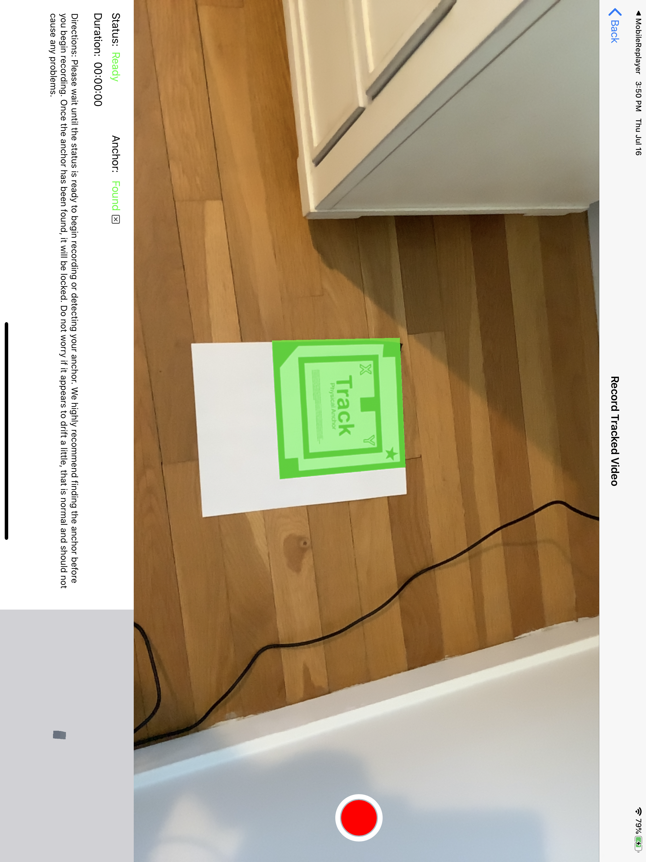

**Step 2:** Press the red record button. As you are recording, you should see your position within your space being mapped out in the bottom right corner.

**Step 3:** Press the red button again to end recording and save the video.